PIZZA SALES SQL QUERIES

KPI’s

Total Revenue:
SELECT SUM(total_price) AS Total_Revenue FROM pizza_sale
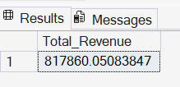

Average Order Value:
SELECT SUM(total_price) / COUNT(DISTINCT order_id) AS Avg_Order_Value from pizza_sales;
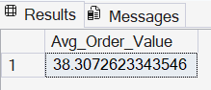

Total Pizzas Sold:
SELECT SUM(quantity) AS Total_pizza_sold FROM pizza_sales;
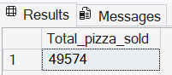

Total Orders:
SELECT COUNT(DISTINCT order_id) AS Total_Orders FROM pizza_sales;
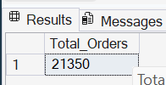

Average Pizzas Per Order:
SELECT CAST(CAST(SUM(quantity) AS DECIMAL(10.2)) / CAST(COUNT(DISTINCT order_id) AS DECIMAL(10,2)) AS DECIMAL(10,2)) AS Avg_Pizzas_per_order FROM pizza_sales;
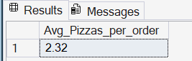

Hourly Trend for Total Pizzas Sold

SELECT DATEPART(HOUR, order_time) AS order_hour, SUM(quantity) AS Total_pizzas_sold
FROM pizza_sales
GROUP BY DATEPART(HOUR, order_time)
ORDER BY DATEPART(HOUR, order_time);
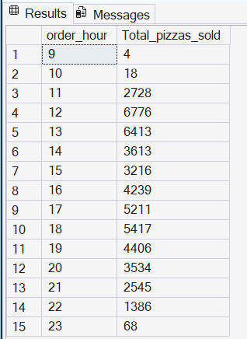

C.Weekly Trend for Orders
SELECT DATEPART(ISO_WEEK, order_date) AS week_number, YEAR(order_date) AS order_year, COUNT(DISTINCT order_id) AS Total_orders
FROM pizza_sales
GROUP BY DATEPART(ISO_WEEK, order_date), YEAR(order_date)
ORDER BY DATEPART(ISO_WEEK, order_date), YEAR(order_date);
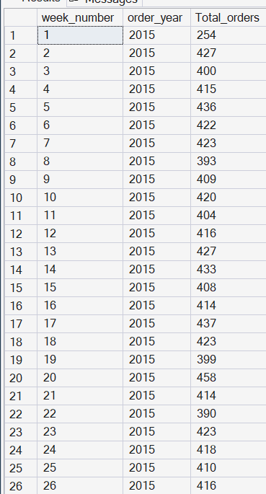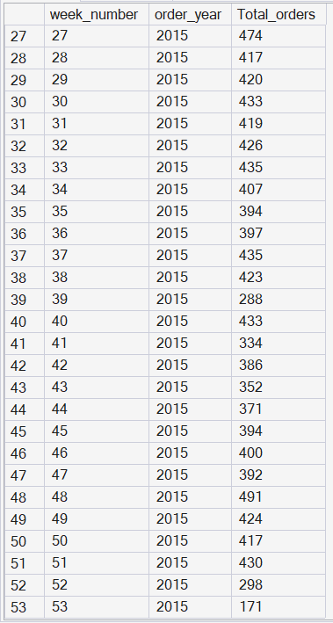

D.Daily Trend for Total Orders
SELECT DATENAME(DW, order_date) AS order_day, COUNT(DISTINCT order_id) AS total_orders
FROM pizza_sales
GROUP BY DATENAME(DW, order_date);
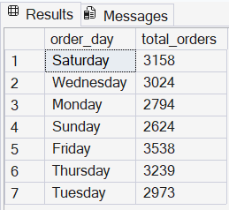

E.% of Sales by Pizza Category
SELECT pizza_category, CAST(SUM(total_price) AS DECIMAL(10,2)) total_revenue, CAST(SUM(total_price) * 100 / (SELECT SUM(total_price) from pizza_sales) AS DECIMAL(10,2)) AS PCT
FROM pizza_sales
GROUP BY pizza_category;
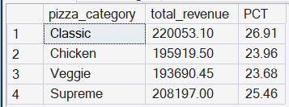

F.% of Sales by Pizza Size
SELECT pizza_size, CAST(SUM(total_price) AS DECIMAL(10,2)) AS total_revenue, CAST(SUM(total_price) * 100 / (SELECT SUM(total_price) from pizza_sales) AS DECIMAL(10,2)) AS PCT
FROM pizza_sales
GROUP BY pizza_size
ORDER BY pizza_size;
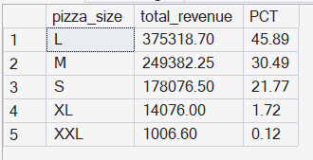

G.Top 5 Pizzas by Revenue
SELECT TOP 5 pizza_name, SUM(total_price) AS Total_Revenue FROM pizza_sales
GROUP BY pizza_name
ORDER BY Total_Revenue DESC;
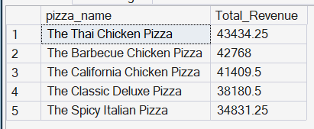

H.Bottom 5 Pizzas by Revenue
SELECT TOP 5 pizza_name, SUM(total_price) AS Total_Revenue FROM pizza_sales
GROUP BY pizza_name
ORDER BY Total_Revenue ASC;
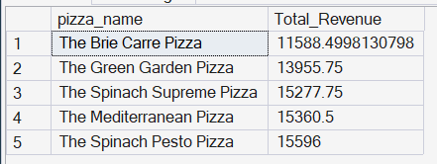

I.Top 5 Pizzas by Quantity
SELECT TOP 5 pizza_name, SUM(quantity) AS Total_Quantity FROM pizza_sales
GROUP BY pizza_name
ORDER BY Total_Quantity DESC;
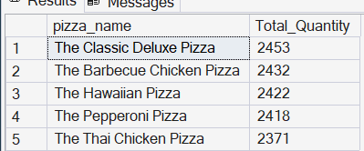

J.Bottom 5 Pizzas by Quantity
SELECT TOP 5 pizza_name, SUM(quantity) AS Total_Quantity FROM pizza_sales
GROUP BY pizza_name
ORDER BY Total_Quantity ASC;
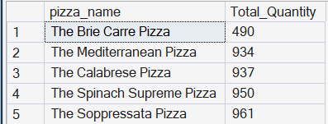

K.Top 5 pizzas by Total Orders
SELECT TOP 5 pizza_name, COUNT(DISTINCT order_id) AS Total_Orders FROM pizza_sales
GROUP BY pizza_name
ORDER BY Total_Orders DESC;
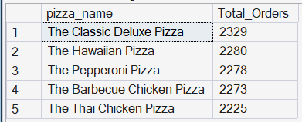

L.Bottom 5 pizzas by Total Orders
SELECT TOP 5 pizza_name, COUNT(DISTINCT order_id) AS Total_Orders FROM pizza_sales
GROUP BY pizza_name
ORDER BY Total_Orders ASC;
